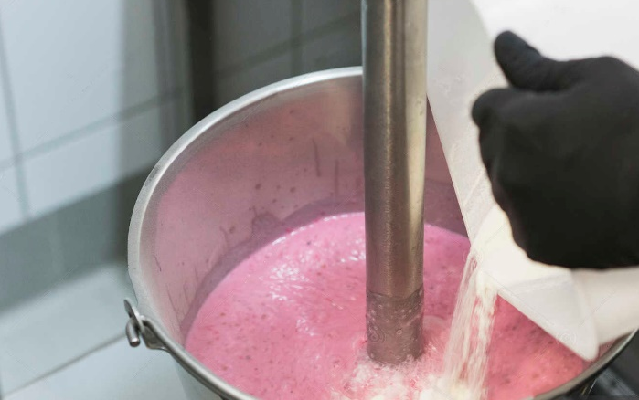
Hygienic and durable stainless steel production vessels, for cost-effective mixing and blending in the Pharmaceutical, Chemical, Food
and Personal Care industries

Our dedicated technical department are delighted to offer their expertise to design and build bespoke vessels, including jacketed vessels, low pressure vessels, mixing vessels and complete processing systems.

Step 1:
Simply answer the questions below, and we will provide a feasibility price for your project.

Step 2:
When you are ready to move to a firm quote to build, we will arrange a consultative call to support the thinking around the bespoke needs of your project.
Please answer the questions as fully as you can. In case of any queries, your dedicated sales representative will be very happy to assist.

1, What is your required vessel working capacity in Litres?
2, What material of construction is required? E.G: 304 or 316L stainless steel.
Please note: if unspecified, 316L is the default choice for bespoke vessels.
☐ 316L grade
☐ 304 grade
3, Are there any requirements to heat or cool your product(s) during the mixing process?
☐ Yes
☐ No
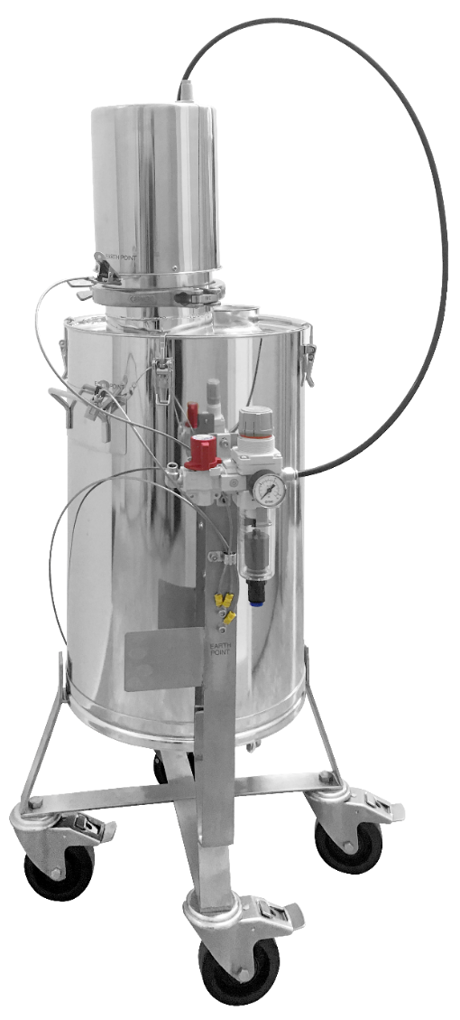
If yes,
- Heating Process
Please specify the temperature from which the product should be heated, to what temperature (EG: to heat the mixed products from ambient temperature to 60 °C within 1 hour)
Please specify:
- The initial product temperature:
- The aimed product temperature:
- How fast the product should be heated:

- Cooling Process
Please specify the temperature from which the product should be cooled, to what temperature (EG: to cool the mixed products from 60 °C to 24 °C within 1 hour)
Please specify:
- The initial product temperature:
- The aimed product temperature:
- How fast the product should be cooled:

4, Is there any internal pressure requirement for your vessel?
☐ No
☐ Yes – please share some details, EG: URS…
☐ I don’t know – your sales representative will connect with you to provide assistance

5, Are any outlets required, including sanitary outlets?
☐ No
☐ Yes
☐ I don’t know – your sales representative will connect with you to provide assistance
If yes, please select any/all that apply:
☐ Tri-Clamp Ball
☐ Butterfly Valve
☐ Other – please share some details…
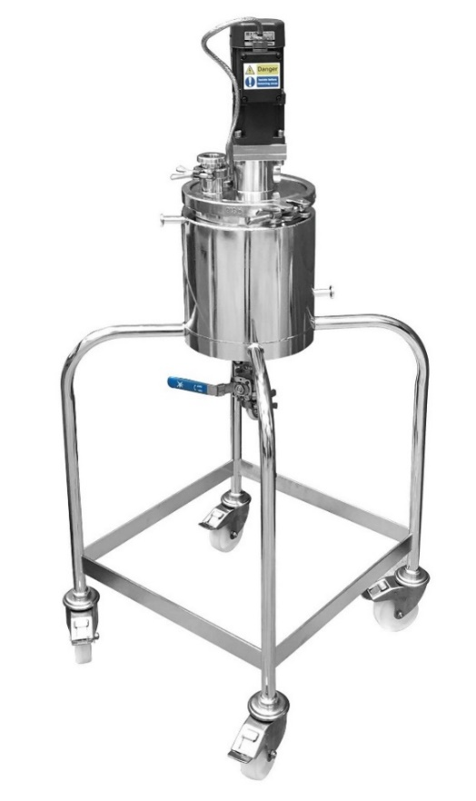
6, What openings are required on the lid? Select any/all that apply.
☐ No openings required
☐ Port for Mixer
☐ Port for Product Adding
☐ Port for Process Monitoring
☐ Site Glass
☐ Other – please share some details…
☐ I don’t know – your sales representative will connect with you
to provide assistance

7, Is there a specific requirement for your vessel base? E.G: Flat or
Conical Bottom. Please use the drawings below to inform your answer.
☐ No special requirement
☐ Flat Bottom with Radiused Corners
☐ Flat Bottom set at 2 degree slope, to drain to valve in the corner
☐ Conical Bottom
☐ Dished Bottom
☐ Other – please share some details…
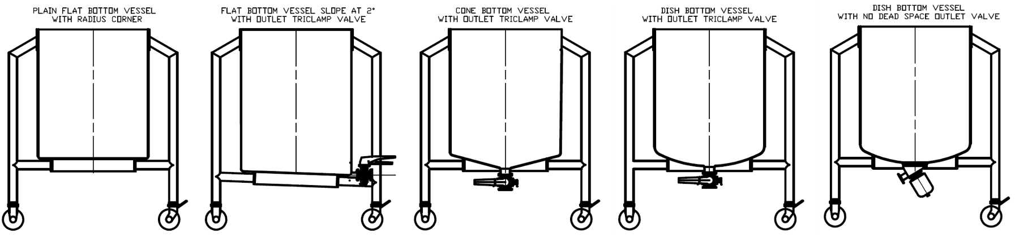

8, Is there a specific requirement for the vessel surface finish, both internal and external?
Please note: Our standard is 0.4µm Ra welds ground for product contact, and 0.8µm Ra welds
as laid for other surfaces.
☐ No
☐ Yes – please share some details…

9, What is the viscosity of each product to be mixed at each processing stage, including the
finished product? Please select the product viscosities which most closely match your own,
from the common examples below:
Alternatively, if you know the viscosity, please state it here (cPs) or (mPasec):

Material | Approximate Viscosity at Room Temperature  (in Centipoise)
☐ Water | 1
☐ Milk | 3
☐ Motor Oil | 85 - 900
☐ Honey | 10,000
☐ Condiments (EG: Ketchup, Mustard) | 50,000 – 70,000
☐ Sour Cream | 100,000
☐ Peanut Butter | 250,000

10, Do you know of any potential difficulties in processing the products, for example coagulation/
lumpy mix/emulsion?

☐ No
☐ Yes – please share some details…

11, Are there any other extra requirements specific to your site – E.G: Load cell mounted,
Cleanroom location, etc?
☐ No
☐ Yes – please share some details…

12, Is there an ATEX requirement? Explanation of ATEX – if you have dust/fumes which mixed
with air, which could ignite (flammable) if there is an ignition source (may cause fire or
explosion).
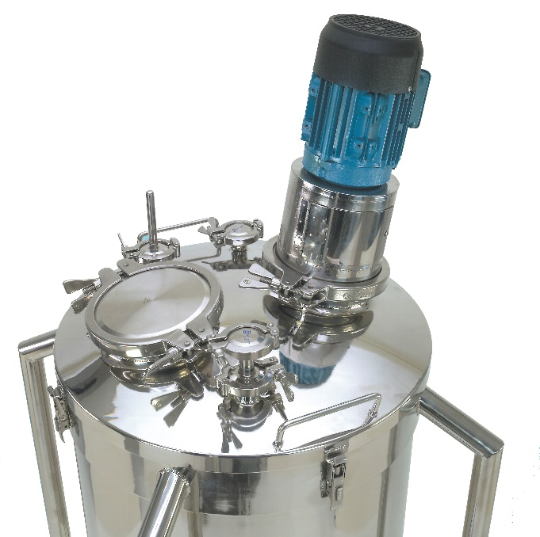
☐ No
☐ Yes
If yes – do you know which zone?
☐ Category 1 /Zone 0
This is for area where explosive mixtures are present
continuously, for long periods or frequently
☐ Category 2/Zone 1
This is for area where explosive mixtures are likely to occur
occasionally
☐ Category 3/Zone 2
This is for area where explosive mixtures occur
infrequently and for short periods of time
☐ Unknown
Is the hazard gas, dust or both?
☐ Gas
☐ Dust
☐ Both
13, Is any accompanying certification required?
☐ No
☐ Yes – please share some details…

Thank you very much indeed for completing the questionnaire – please return it to your dedicated sales representative.
They will be back in touch with you as soon as possible to provide pricing, and give guidance on the next steps involved in the project.
In the meantime, if you have any questions or if Pharma Hygiene Products can be of any further assistance, please don’t hesitate to ask.

